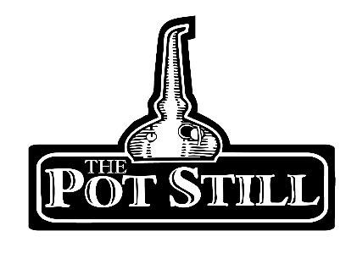
Booking a private whisky tasting

At The Pot Still we offer private whisky tasting sessions and gift vouchers, for birthdays, anniversaries, hen/ stag parties, Christmas, whisky clubs or just because you want to get together with your friends and enjoy some great whisky.
We are able to completely tailor your tasting experience to whatever suits you or your group.
If you have a particular style or brand of whisky you would like to try, just let us know. If you have a budget you would like to stick to, just let us know or if you would like to taste more or less than the standard 6 samples, we can arrange that for you.

We are able to host tasting sessions anytime except from a Friday or Saturday after 2pm. We do not have a minimum number of people required to place a booking but our maximum number is 24 people.
Our standard tasting starts at £30 per person for 6 whisky samples.
Your whisky tasting is likely to last around 1.5hrs depending on the size of the group.
On the day of your tasting you will be greeted by the member of staff who will be hosting your tasting and shown to your table. Your whiskies will be set on your table and your host will talk you through each of your whiskies as you taste, please feel free to ask as many questions as you like, but please don’t heckle.

To book your whisky tasting session or if you require any further information please contact Geraldine at (0141)333-0980 or geraldine@thepotstill.co.uk

We reserve the right to refuse anyone entry into the whisky tasting session or bar.

