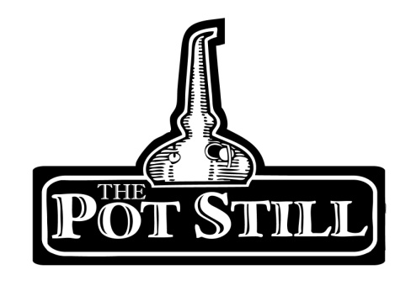
This information sheet is provided to give you a bit of insight into the flight that you have chosen and the distilleries or regions that the whisky has come from.
If you have any other questions or would like any other information, please do not hesitate to ask our knowledgeable staff.
Tour around Scotland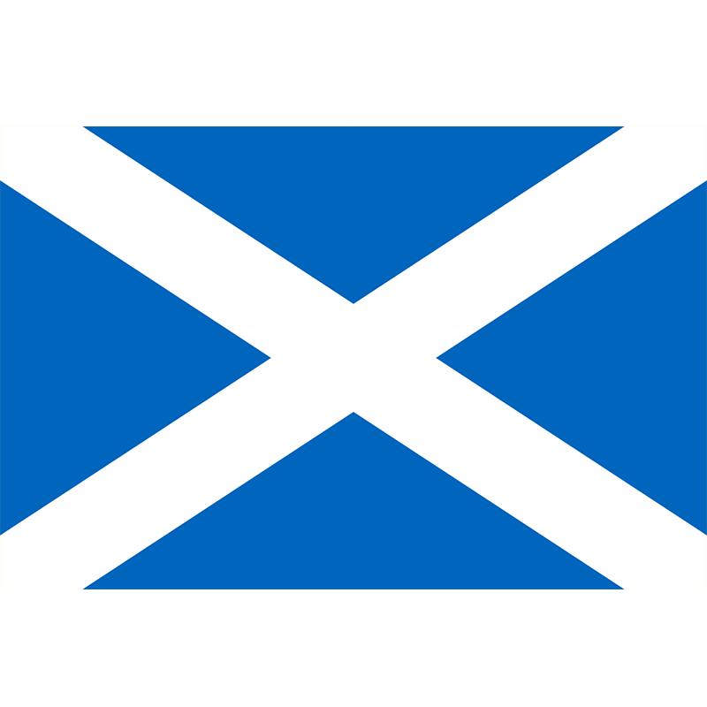
This flight is our wee tour around each of the whisky making regions of Scotland, giving you a taste of some of the flavours of Scottish whisky. There is 1 whisky from each region for you to enjoy.

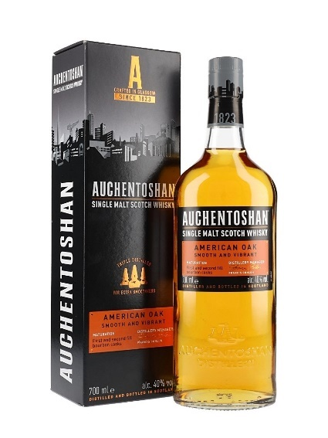
1. Auchentoshan American Oak – Lowland – 40%
pron. Awk-in-taw-shin
Gaelic “Corner of the Field”
Auchentoshan is one of the closest distilleries to Glasgow being around 20 mins outside of the city. Auchentoshan is the only working distillery in Scotland which triple distils their entire range.
The ‘American Oak’ expression is a non-age statement bottling, matured in both first fill and second fill American bourbon casks.
The American Oak is soft and fruity. It has a vanilla and citrus nose with a smooth, creamy and zesty palate.

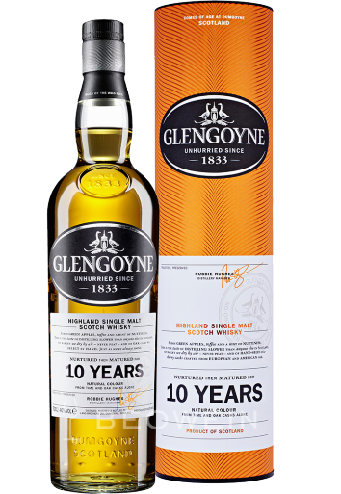
2. Glengoyne 10yr – Highland – 40%
pron. Glen-goy-n
Gaelic “Valley of the Geese”
Glengoyne is the closest Highland distillery to Glasgow, around 40 mins from the city. It sits on the road that divides the Highland and Lowland regions. Glengoyne has one of the slowest distillations of all the Scottish distilleries producing a very gentle spirit.
Glengoyne 10yr is aged in sherry casks crafted from European and American oak.
The 10yr expression has a sweet toffee nose with fresh green apple. It is fresh and slightly nutty on the palate.
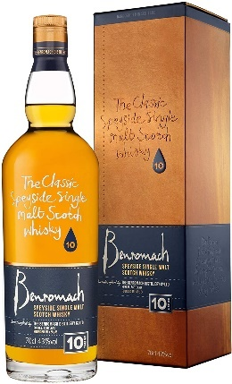
3. Benromach 10yr - Speyside – 43%
pron. Ben-ro-mak
Gaelic “Shaggy Mountain”
Benromach distillery is from a small town called Forres located in Scotland’s largest whisky making region.
It is matured in 80% bourbon cask and 20% sherry cask which helps give a complexity to the whisky.
The 10yr expression is nicely balanced with both sweet sherry and light peat notes on the nose with a rich, fruity and spicy palate.
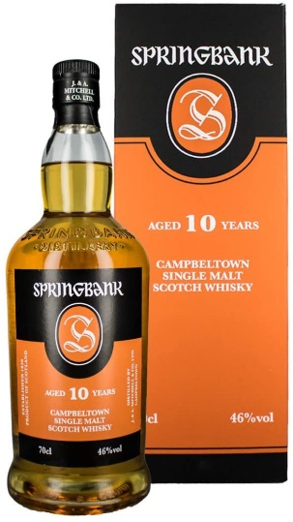
4. Springbank 10yr - Campbeltown – 46%
pron. Spring-bank
Springbank is one of the 3 remaining distilleries in Campbeltown. Springbank is one of the only distilleries in Scotland to complete the whole whisky making process on site.
This expression is matured in 60% bourbon and 40% sherry casks
The 10yr has a nose of pears, peat and vanilla and on the palate is sweet, spicy and malty.
5. Ledaig 10yr - Islands – 46.3%
pron. Led-chig
Gaelic “Safe Haven”
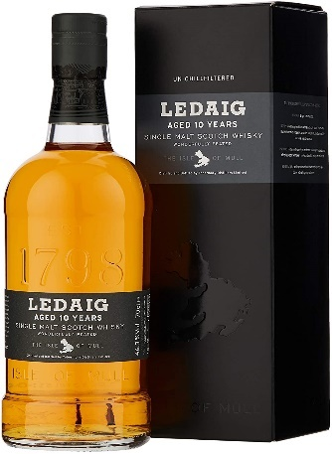
Ledaig is from the Tobermory distillery on the Isle of Mull and is currently the only whisky distillery on the island.
This expression of Ledaig is aged in American bourbon oak and European sherry oak.
On the nose it has floral, seaside smoke and maltiness while the palate is peppery with a subtle fruity sweetness and more smoke.

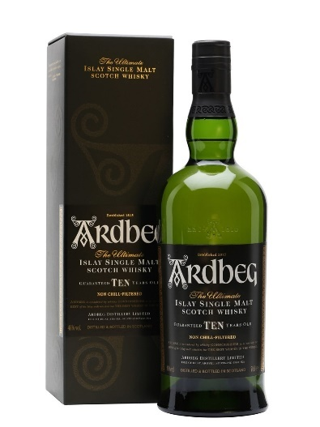
6. Ardbeg 10yr - Islay – 46%
pron. Ard-beg
Gaelic “Small Promontory”
Ardbeg is one of the oldest distilleries on the island of Islay, established in 1815.
Ardbeg 10 is aged in ex-bourbon barrels.
It has a smoky, brininess on the nose with a palate of peppery citrus and tarry peat.

