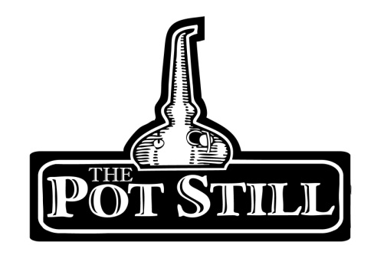
Your information sheet is provided just to give you a bit of insight into the flight that you have chosen and the distilleries or regions that the whisky has come from.
If you have any other questions or would like any other information, please do not hesitate to ask our knowledgeable staff.
Sherry Bomb
Highly regarded in the industry, sherry plays a huge role in the flavour of many Scottish whiskies. Here are our some of our favourites!
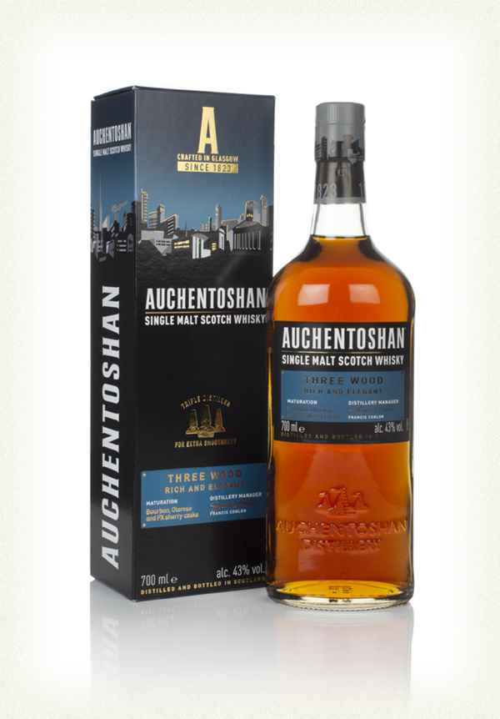
1. Auchentoshan Three Wood – Lowlands – 43%
pron. Awk-in-taw-shin
Gaelic “Corner of the Field”
A good way to begin a sherry tasting. Auchentoshan Three Wood is matured in a combination of bourbon, oloroso and pedro ximenez casks.
Although this whisky is triple distilled to give a more delicate spirit but is still highly flavoursome.
The nose gives toffee and chocolate notes with hints of nut, followed by a palate reminiscent of a forest gateau. The finish is treacle and wood with a slight citrus bitterness.

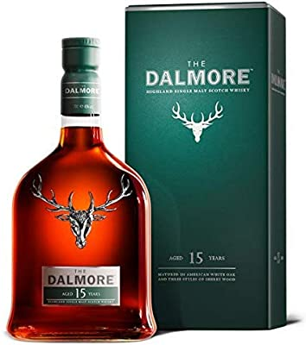
2. Dalmore 15 –Highlands – 40%
pron. dal-more
Translation “Big Meadowland”
Matured in matusalem, apostoles and amoroso sherry, the Dalmore 15 is an example of the potential variety of flavours that can be imparted on sherry.
The nose is orange and nutmeg while the palate is a much richer mandarin, vanilla and ginger spice with dark chocolate. The finish sees the return of the orange notes and bitter coffee.
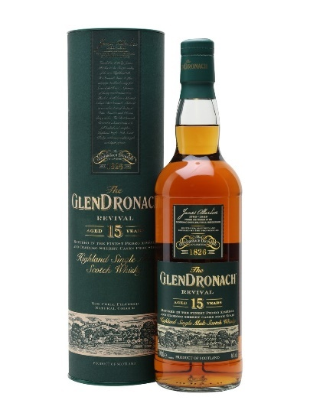
3. Glendronach 15 Revival – Highlands – 46%
pron.glen-draw-nick
Translation “Valley of the Blackberries/Brambles”
After ceasing in 2015, the return of the Glendronach 15 was a welcomed surprised to sherry whisky lovers. It embodies the signature style of Glendronach using pedro ximenez and oloroso sherry casks for maturation.
On first nose, the nose of cherries and dark fruits is unmistakable. On the palate the fruits are fresh and cherries alongside muscovado sugar. The finish is short and sweet, a slight herbal note with honey and chocolate.
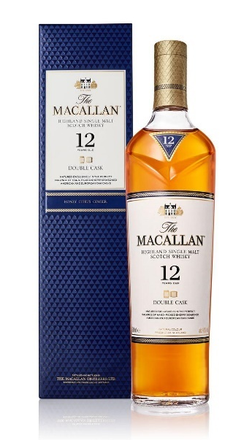
4. Macallan 12 Double Cask –Speyside – 40%
pron. mac-al-in
From a range of 3 different standard Macallan 12 expression, this one stands out as the best of both worlds using both American and European seasoned sherry oak.
On the nose it has raisin and dried prune notes. The palate is spicier with a nice blend of cinnamon swirls and orange marmalade. The finish is similar, a slight sweet spice remains.
5. Glenfarclas 105 – Ballindalloch, Speyside – 60%
pron. glen-far-clas
Translation “Valley of the Green Grass”
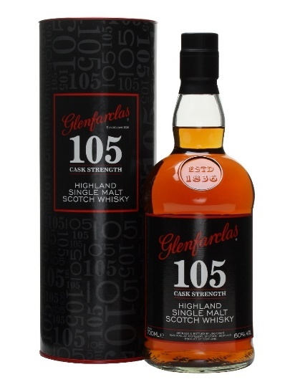
The cask strength non-statement expression of the Glenfarclas range. Although this whisky is matured in a combination of ex-bourbon and ex-sherry casks, it is highly regarded amongst whisky drinkers as one of the best value sherry cask, cask strength whiskies available.
The nose is creamy, nutty and huge sherry body. Spices tickle the taste buds and balance the red fruit and nut tones. The finish leaves a peppery tingle.
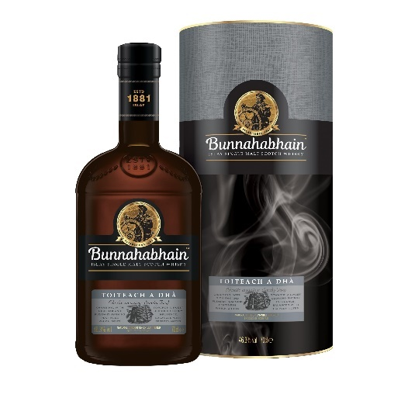
6. Bunnahabhain Toiteach a Dha – Bunnahabhain, Islay – 46.3%
pron. boo-na-ha-vin Toch-ach ah-ghaa
Translation “Foot of the River”
To finish off, a combination of sherry and peat. The Toiteach a Dha translates to smoky two as it is the sequel to the popular Bunnahabhain Toiteach.
Although aged in both ex-bourbon and sherry casks, the sherry casks have imparted a much stronger flavour on this malt.
The nose has hints of sherry and sea salt air. The palate has a warm, peppery peatiness, balanced by the sweet raisins from the oloroso sherry. The finish is dry and peppery.

