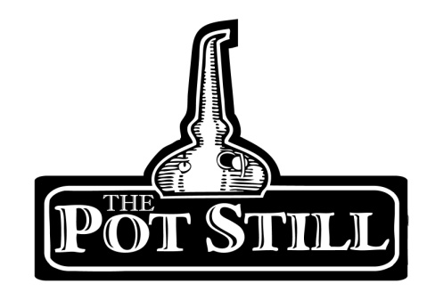
Your information sheet is provided just to give you a bit of insight into the flight that you have chosen and the distilleries or regions that the whisky has come from.
If you have any other questions or would like any other information, please do not hesitate to ask our knowledgeable staff.
Lowland v Speyside
Our Highland versus Islay flight offers 3 delicious whiskies from both the Highland region and Islay. Which ones do you like best?
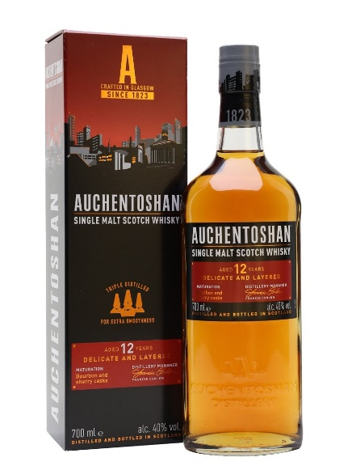
1. Auchentoshan 12yr - Lowlands – 40%
pron. Awk-in-taw-shin
Gaelic “Corner of the Field”
Auchentoshan is the one of the closest distilleries to Glasgow being only about 20 mins outside the city. Auchentoshan is the only working distillery in Scotland which fully triple distils their entire range.
The 12yr expression uses whisky matured in both bourbon and sherry barrels.
This give the whisky a crème-brulee note along with the signature nuttiness from Auchentoshan. On the palate you get more of a toffee and citrus character.

2. 1770 – Lowlands – 46%
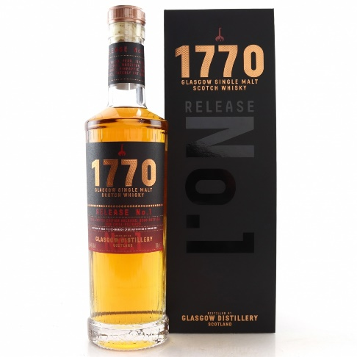
Distilled in one of the Lowlands youngest distilleries, 1770 is distilled in The Glasgow Distillery which originated as a gin distillery. The name 1770 is an ode to an earlier Glasgow Distillery Co which originated in 1770 and sadly closed in the beginning of the 20th century.
The 1770 Original is matured in first-fill bourbon casks and finished in virgin oak.
The nose has a rich fruity note with a grassy freshness leading to muscovado sugar shortbread and honey palate complimented by a finish of subtle, warm spices.
3. Glenkinchie 12yr – Lowlands – 43%
pron. glen-kin-chee
Translation “Glen of Quincey”
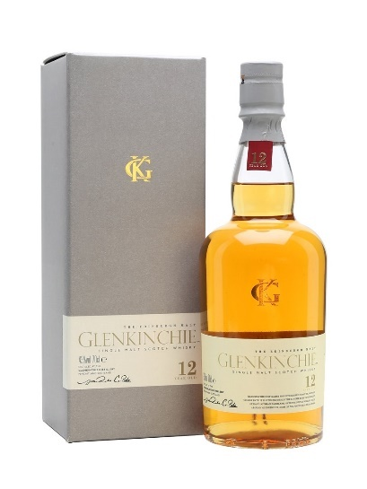
Glenkinchie Distillery is situated just about 30 mins outside of Edinburgh.
The 12yr replaced the old 10yr in 2007. Matured in American bourbon casks.
The nose is quite light, yet fragrant. Notes of fresh cereal and grist, some barley sweetness and a nutty note. The palate is very fruity with notes of Madeira and sweet stewed fruits. The finish is of medium length with notes of cereal and fresh greenness

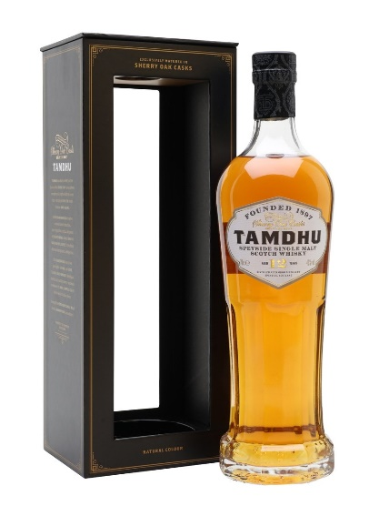
4. Tamdhu 12yr – Speyside – 43%
pron. tam-dhoo
Translation “Little Dark Hill”
Tamdhu is situated near Aberlour along the banks of the river Spey in the Speyside region in Scotland
Tamdhu 12 Year Old is their signature malt and took over their 10yr as the signature release in their slowly maturing range of exquisite whiskies.
Matured exclusively in sherry oak casks, some of the finest in the whisky industry, they ensure every drop is as magnificent now as the founders envisioned over a century ago.
The nose draws you in with sticky orange and cinnamon. The palate is mouth wateringly rich with cooked plums and raspberries with a hint of pastry. The finish has a light cinnamon spice and lingering fruity sweetness.
5. Glenfarclas 10yr – Speyside – 40%
pron. glen-far-clas
Translation “Valley of the Green Grass”
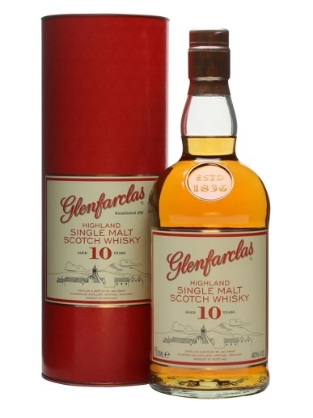
Glenfarclas Distillery is one of the few remaining Scottish distilleries that is still family owned and has been owned by the Grant family for 6 generations.
Tempting sherry-sweet malty tones combine with delicate smokiness, releasing subtle spices are the first thing on the nose. The palate is delicately light, with a mouth-watering combination of buttery shortbread and sherry sweetness. Hints of dried fruit, vanilla, cinnamon and cloves tempt the taste buds further.

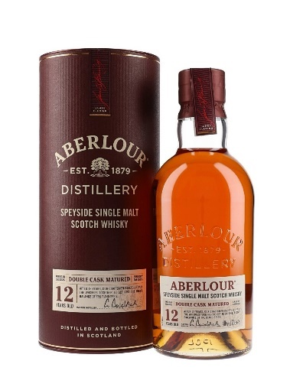
6. Aberlour 12yr – Speyside – 40%
pron. ah-ber-loor
Aberlour also sits along the banks of the river Spey and uses both bourbon and sherry casks to produce their 12yr bottling.
The nose offers soft rounded fruity notes and red apple, the palate moves on to more warm cinnamon and ginger spices. Sherry flavours, toffee chocolate finish off the experience.

