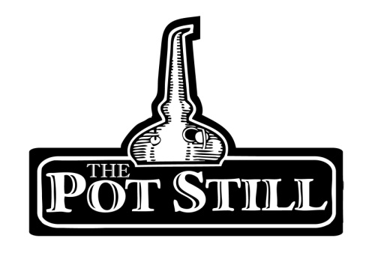
Your information sheet is provided just to give you a bit of insight into the flight that you have chosen and the distilleries or regions that the whisky has come from.
If you have any other questions or would like any other information, please do not hesitate to ask our knowledgeable staff.
Highland v Islay
Our Highland versus Islay flight offers 3 delicious whiskies from both the Highland region and Islay. Which ones do you like best?
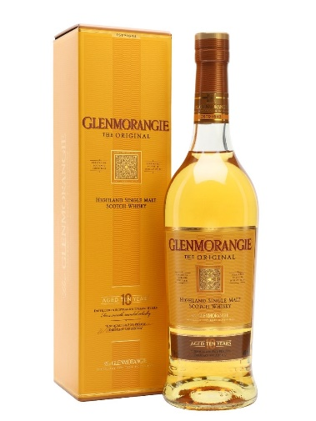
1. Glenmorangie 10yr –Highlands – 40%
pron. Glen-maw-ran-gee
Gaelic “Vale of Tranquillity” or “Vale of Big Meadows”
Glenmorangie boasts the tallest still in Scotland, producing a very delicate spirit. The 10yr is their standard bottling.
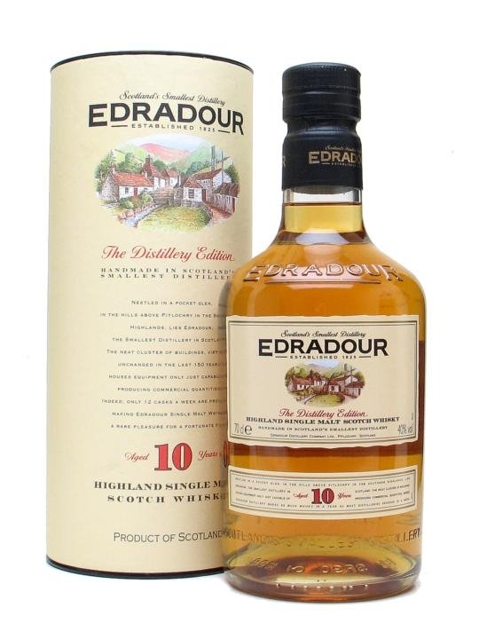
Matured in a mixture of first and second fill ex bourbon casks, the nose offers vanilla and ripe peach. The first flavour on the palette has lots of vanilla opening up to a fresh fruitiness. Ending with a soft orange and peach.
2. Edradour 10yr – Highlands – 40%
pron. ed-rad-oor
Gaelic “Between Two Rivers”
Edradour is the second smallest distillery in Scotland, located in Perthshire’s Pitlochry. They also have a peated range named “Ballechin”
The 12yr is matured in ex sherry barrels leading to a whisky with a woody, dried fruit nose and spicy, sweet caramel apple flavour with a hint of cherry.
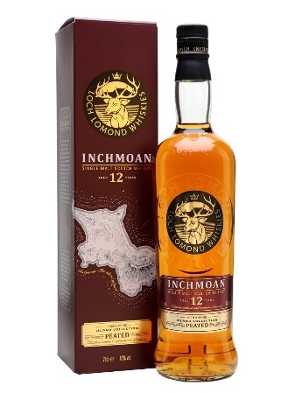
3. Inchmoan 12 – Loch Lomond, Highlands – 46%
pron. inch-mo-an
Translation “Peat Island”
An ode to the island of Inchmoan, located within Loch Lomond, Inchmoan 12 is a peated expression from the Loch Lomond distillery. This expression is aged in recharred American oak and refill bourbon casks.
Although peated, Inchmoan 12 is light in its other flavours. An iodine nose is followed by a sweet honey and vanilla palate with a hint of peppery peat.
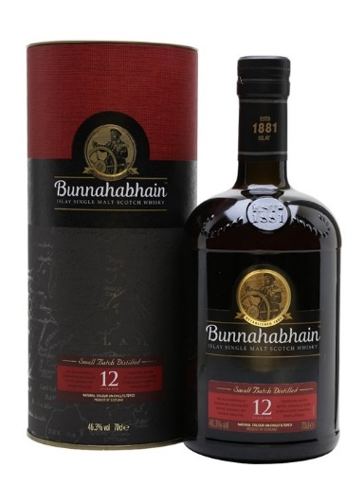
4. Bunnahabhain 12yr – Islay – 46.3%
pron. boo-na-ha-van
Translation “Foot of the River”
Bunnahabhain is one of the few distilleries situated in the north of island of Islay. Bunnahabhain is known for producing both peated and unpeated spirit. The 12 year old is double matured in ex-bourbon and ex-sherry casks.
This expression has a fruit and nut notes with hints of spice with very slight hints of coastal notes but without the influence of peat. A very different style of Islay malt.

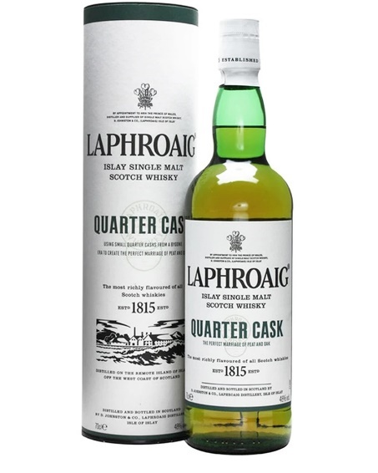
5. Laphroaig ¼ cask – Islay – 48%
pron. la-froyg”
Translation “The Hollow of Broad Bay”
Laphroaig distillery sits on the south coast of Islay. The Quarter cask expression is a non- age statement whisky but uses slightly younger whisky to achieve the product they are looking for. The use of smaller casks helps to give more cask influence to the whisky.
The whisky is lighter in smoke than the standard 10yr expression, with more of a creamy texture with hints of coconut and soft peat.
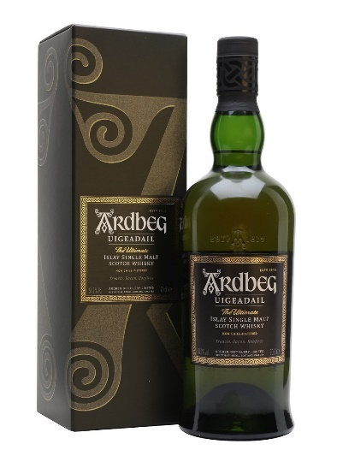
6. Ardbeg Uigeadail – Islay – 54.2%
pron. ard-beg oo-geh-dal
Translation “The Small Promontory”
Ardbeg is from the island of Islay on the west coast of Scotland. The Uigeadail is aged is a combination of ex-american and ex-sherry casks.
It is a punchy, heavily peated Scottish malt. On the nose there is briny sea air and vanilla followed by a classic sweet, citrus smoke.

