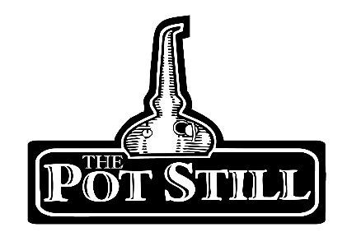
Purchasing your whisky tasting voucher

At The Pot Still we offer private whisky tasting gift vouchers, for birthdays, anniversaries, hen/ stag parties, Christmas, whisky clubs or just cause you want to get together with your friends and enjoy some great whisky.
Deciding on what amount to spend?
Our tasting sessions start at £30 per person, and are available on our website up to £100. If you would like a different value please feel free to get in touch and we can arrange that for you.
All of our vouchers are based on tasting 6 samples if you would like to try more or less whiskies please let us know. The higher the value of your voucher simply enables the recipient to try more expensive samples or to try more samples were possible, the maximum number of samples tasted per session is 10.
We are able to completely tailor your tasting experience to whatever suits you or your group. If you have a particular style or brand of whisky you would like to try just let us know.
Booking your tasting session
We are able to host tasting sessions anytime except from a Friday or Saturday after 1.30pm. All tasting sessions must be booked in advance. We do not have a minimum number of people required to place a booking but our maximum number is 24 people.
Your whisky tasting is likely to last around 1.5hrs depending on the size of the group.
On the day of your tasting you will be greeted by the member of staff who will be hosting your tasting and shown to your table. Your whiskies will be set on your table and your host will talk you through each of your whiskies as you taste, please feel free to ask as many questions as you like, but please don’t heckle.
To book your whisky tasting session or if you require any further information please contact Geraldine at 0141 333-0980 or geraldine@thepotstill.co.uk

